

The Peples Republic of Bangladesh
Minstry of Health &Family Welfare (Health Service Division)
Health Economic Unit (HEU). Shasta Surakkha Kormochuci (SSK)
Topkhana Road, Dhaka-1000

Visit Report: Bhuapur Upazilla Health Complex, Tangail
Date of Visit: 27/07/22 Time: 9:30 AM.
Visitor: Mr. Azmal Kabir, National Consultant (HEU) of MoHFW,
Dr. Md. Emdadul Haque, National Consultant (HEU) of MoHFW&
Mr. Mosharrof Hossain, Program Manager, SSK, Tangail District

1. The UH&FPO of the hospital Dr. Abdus Sobhan was in leave because of he was COVID-19 positive. We Discussed with RMO, other MOs, nurses and medical technologist (Lab) about the role of the service providers to serve the SSK indoor patients. A powerpoint presentation and Video on SSK and Building blocks of Chougacha, Jhinaidah Model was presented for them. After the presentations, a question Answer session was held and clarify the role of the induviduals.
2. After meeting, we visited the SSK booth and their activities, learned their challenges and discussed on overcoming the challenges.
3. Then we visited outdoor of Upazila Health Complex. In outdoor, we observed the Mathernal health service delivery system, quality of maternal health care, their privacy and discussed the role of gynecologist and midwives. We also shared ideas with them regarding health education delivery system, pathology service delivery system and 24/7 blood transfusion system.
4. After that we visited indoor, labor room and OT of the hospital. We observed the clinliness of different sections of indoor and toilet management. We observed the clinliness and quality of standard labor room. We advised them to remove the unwanted items from the labor room. We observed the OT, it was clean and beautiful; but there were some unwanted items which we advised to remove from OT.
5. We visited the emergency department. As previous visit we advised them to improve their instrument sterilization which we found satisfactory in recent visit.
6. We observed the hospital premises. There was a beautiful garden in the premises. But there was no cycle stand close to the main gate of the hospital, that’s why many motor cycle were parked within the hospital corridors. We left the hospital premises at 2pm.
8. At 7pm we visited the public library of Tangail district and met with the secretary and some of the executive members of that institute. We learned about their opinions regarding SSK in Tangail district and Govt. health service delivery system.
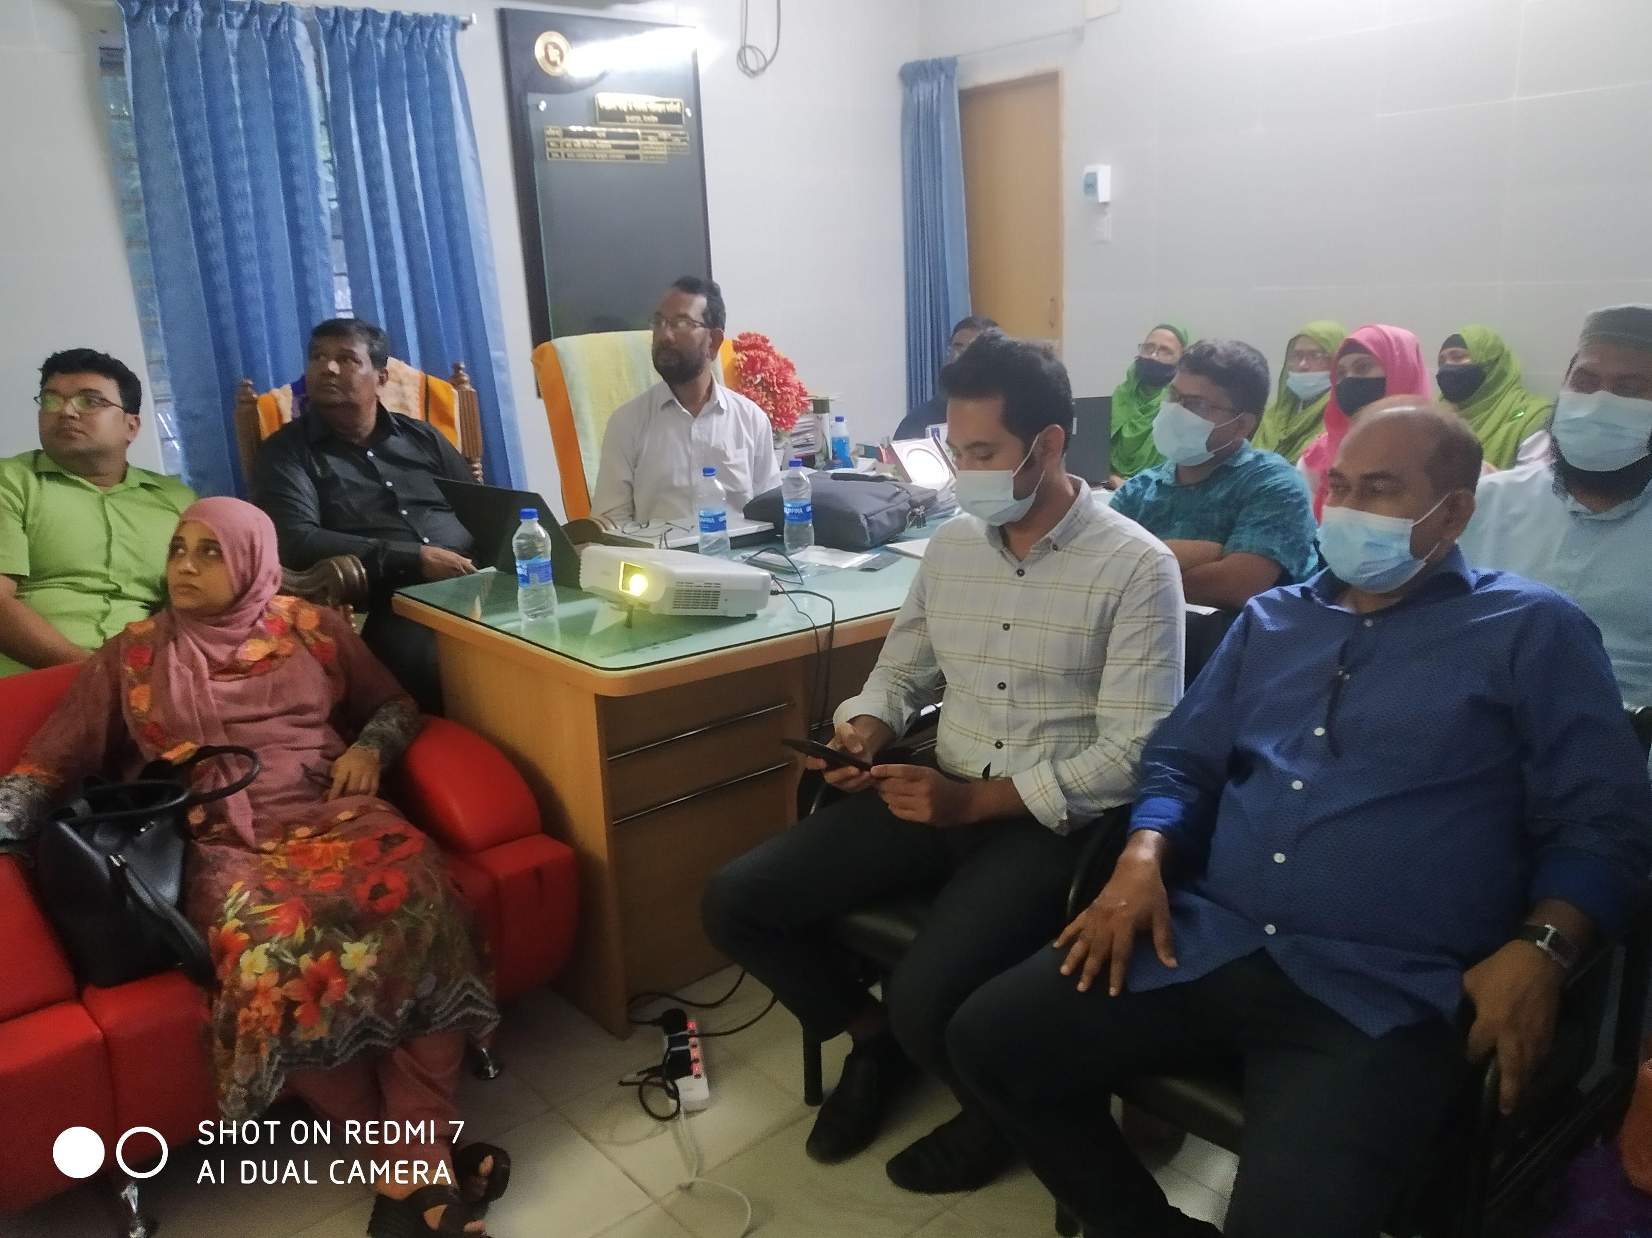

Fig: Meeting with the service providers at Bhuapur UHC

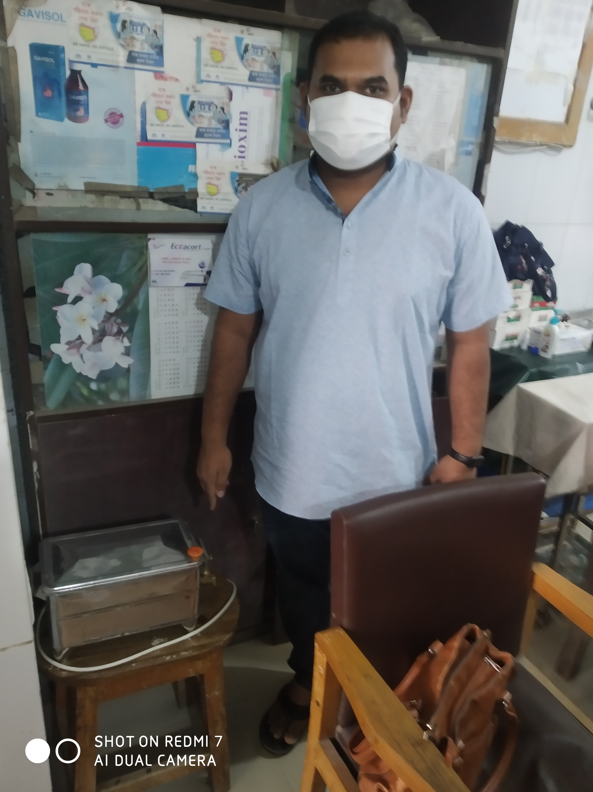
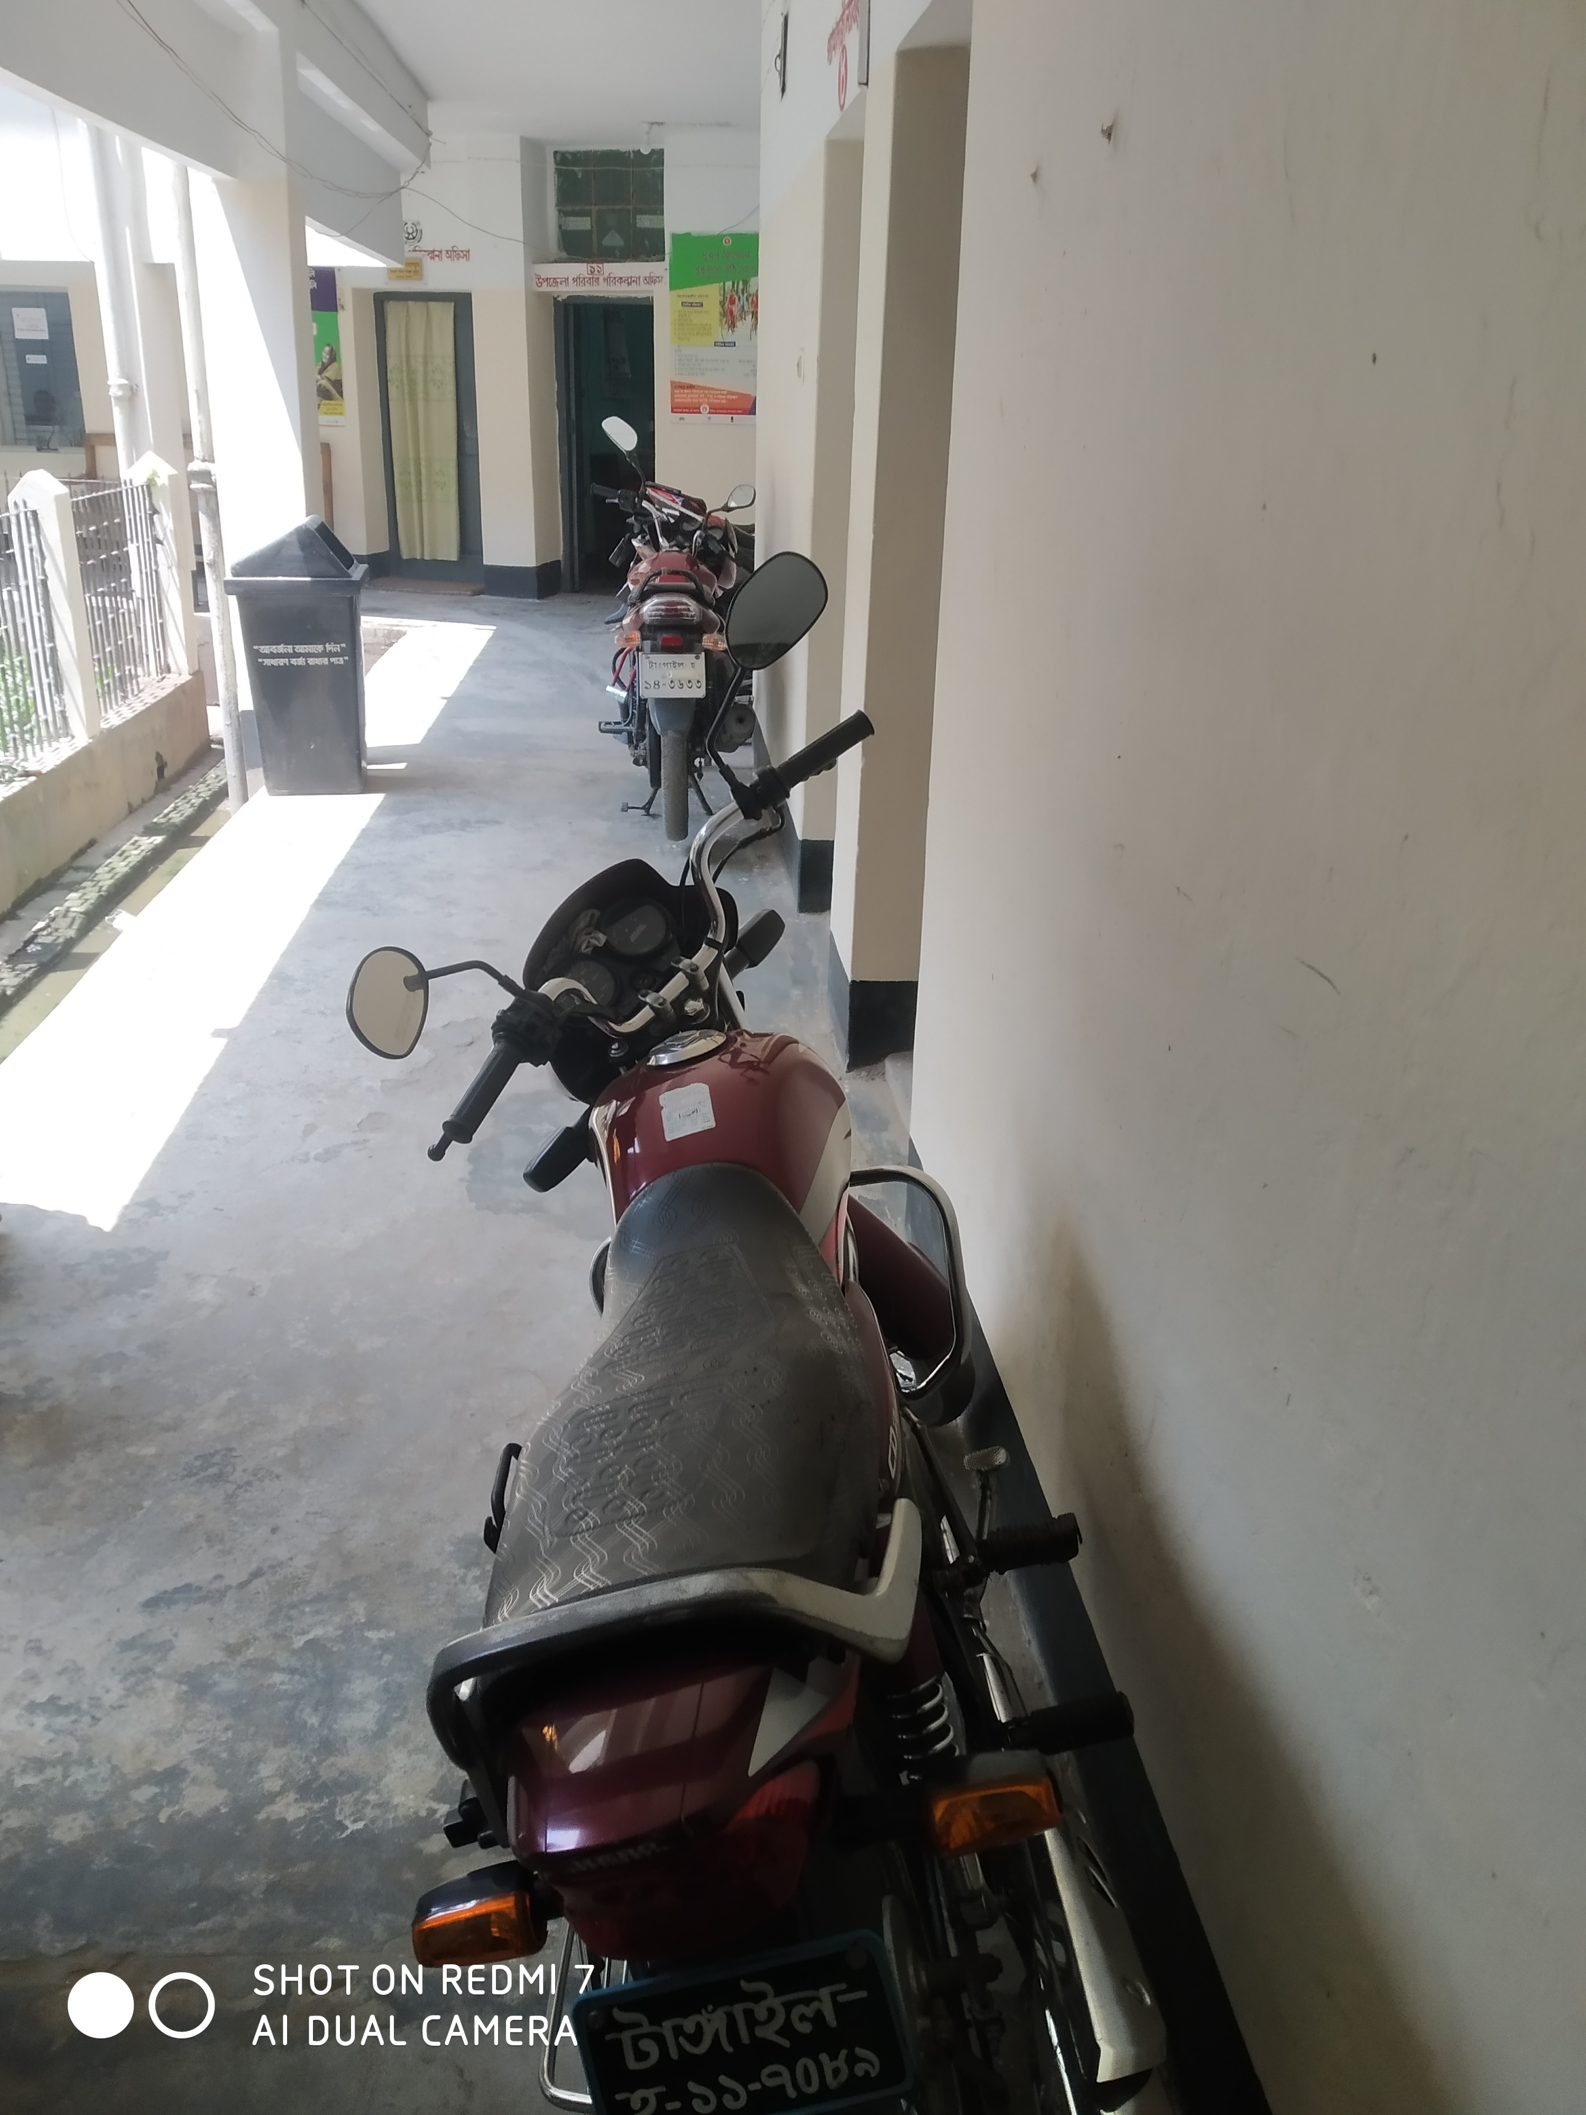

Fig: Left- Sterilizer machine in the emergency;
Right- Motorcylcle parked in hospital corridor
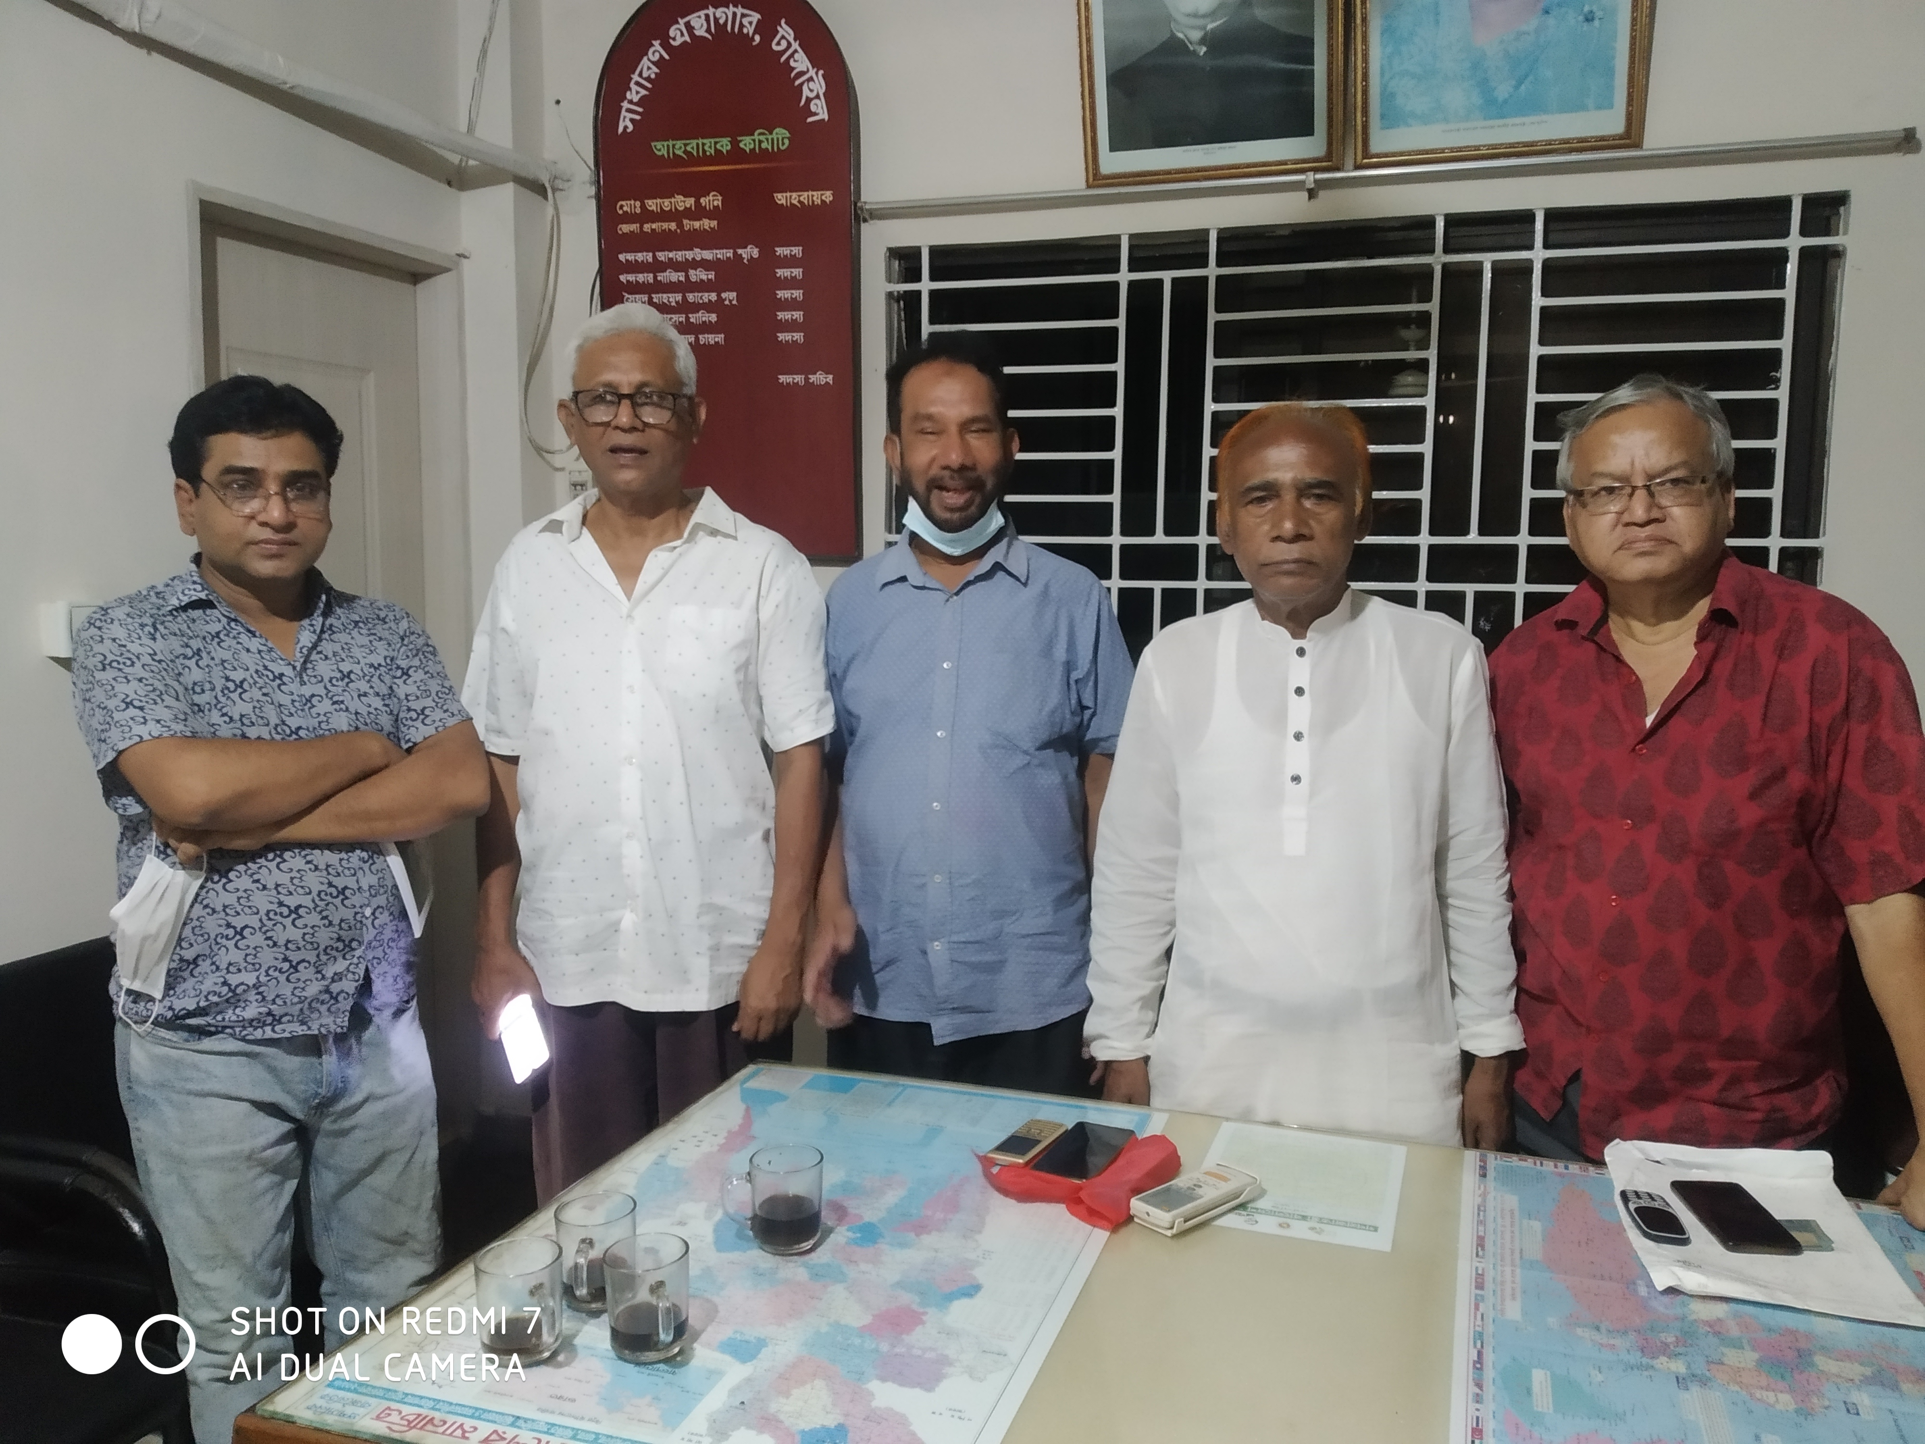

Fig: Meeting with secretary and executive members of Public Library
Visit Report: Tangail District Hospital, Sheikh Hasina Medical College Hospital, Nagorpur Upazila Health Complex, Tangail
Date of Visit: 28/07/22 Time: 8:30 AM.
Visitor: Mr. Azmal Kabir, National Consultant (HEU) of MoHFW,
Dr. Md. Emdadul Haque, National Consultant (HEU) of MoHFW&
Mr. Mosharrof Hossain, Program Manager, SSK, Tangail District

1. At 8:30am we visited the SSK booth of Tangail district hospital and met with the Superintendent Dr. Sadikur Rahman, RMO Dr. Lutfur Rahman Azad and Dr. Nurul Islam Shamim (Sr. Consultant, Paediatrics). We learned that 33 SSK referred patients was admitted in District hospital on 27 July 2022.
2. We discussed regarding the overall situation of the hospital and it is running well. But the bed occupancy rate was nearly 200%. We requsted him to change the SSK booth room because of the room was very small and not well accommodated. He assured us that he will take necessary action as soon as possible regarding this matter.
3. We visited the neonatal unit and labor room. The NICU was excellent and they were managing the room effectively by local initiatives. They are managing it since 2018. The labor room was very small and congested as nearly 4-5 normal delivery is being conducted here everyday. Caesarian section was not conducted during night in the hospital.
4. We visited Sheikh Hasina Medical College Hospital at 10am and met with the Director of the medical college hospital Prof. Dr. Mohammad Ali Khan. Outdoor services have been started but indoor service is not yet started because the lack of medical technologist (8-10 in number) and small number of nurses. He assured us immediately he will start the indoor services of the hospital.

5. We visited Nagorpur Upazila Health Complex at 12:30pm. We met with the UH&FPO Dr. Rokonuzzaman. We visited SSK booth and pharmacy of the hospital. We Discussed UH&FPO, other MOs, nurses and medical technologists (Lab) about the role of the service providers to serve the SSK indoor patients. A powerpoint presentation and Video on SSK and Building blocks of Chougacha, Jhinaidah Model was presented for them. After the presentations, a question Answer session was held and clarify the role of the induviduals. RMO was absent as he was in a leadership training in Dhaka.
6. Then we visited the hospital premises. We noticed that a beautiful cycle stand is functioning close to the main gate. It was constructed by HED with the support of Health Economic Unit. We left the hospital at 2:30pm.

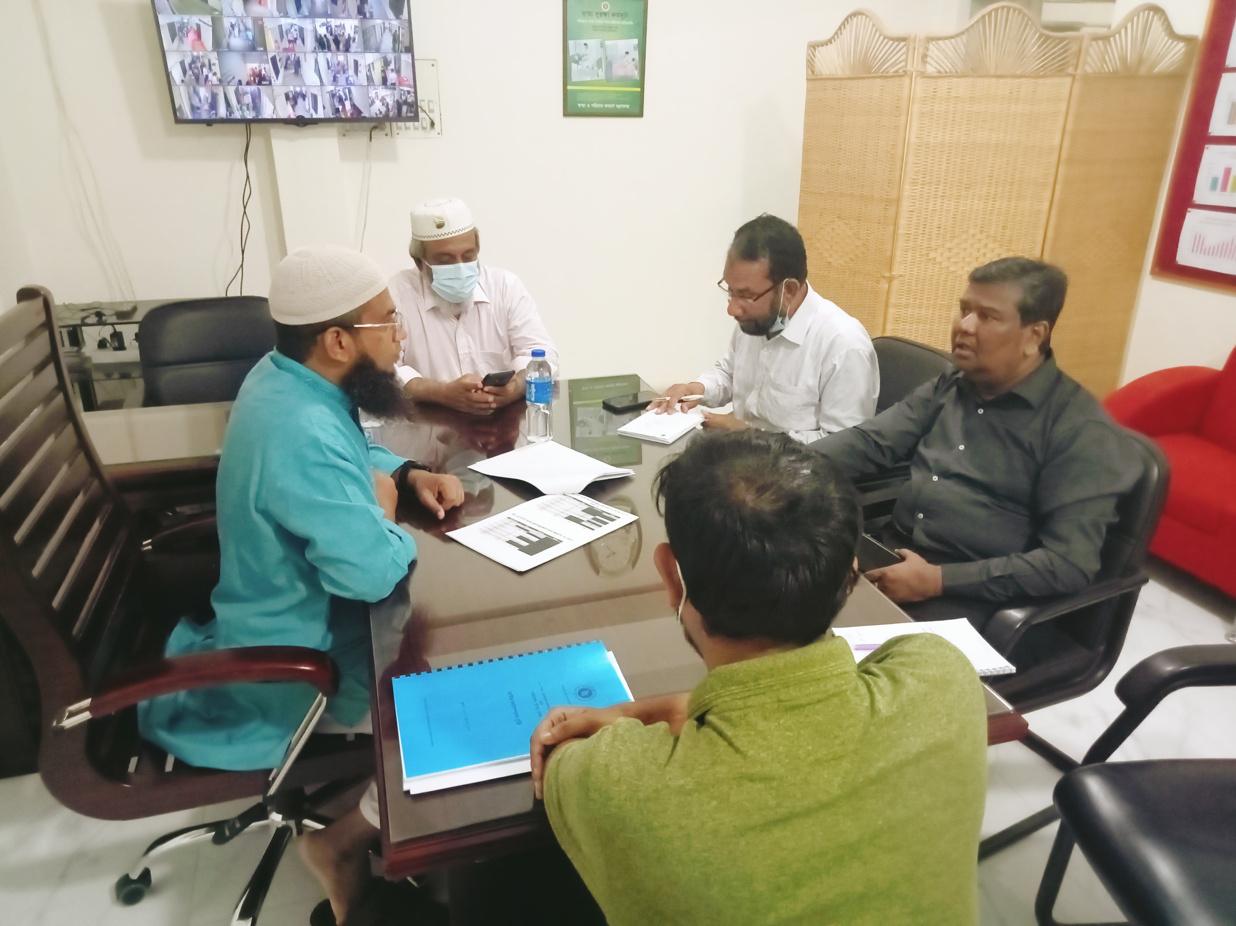

Fig: Discussion with Superintendent, RMO and Senior consultant Pediatrics at
Tangail District Hospital

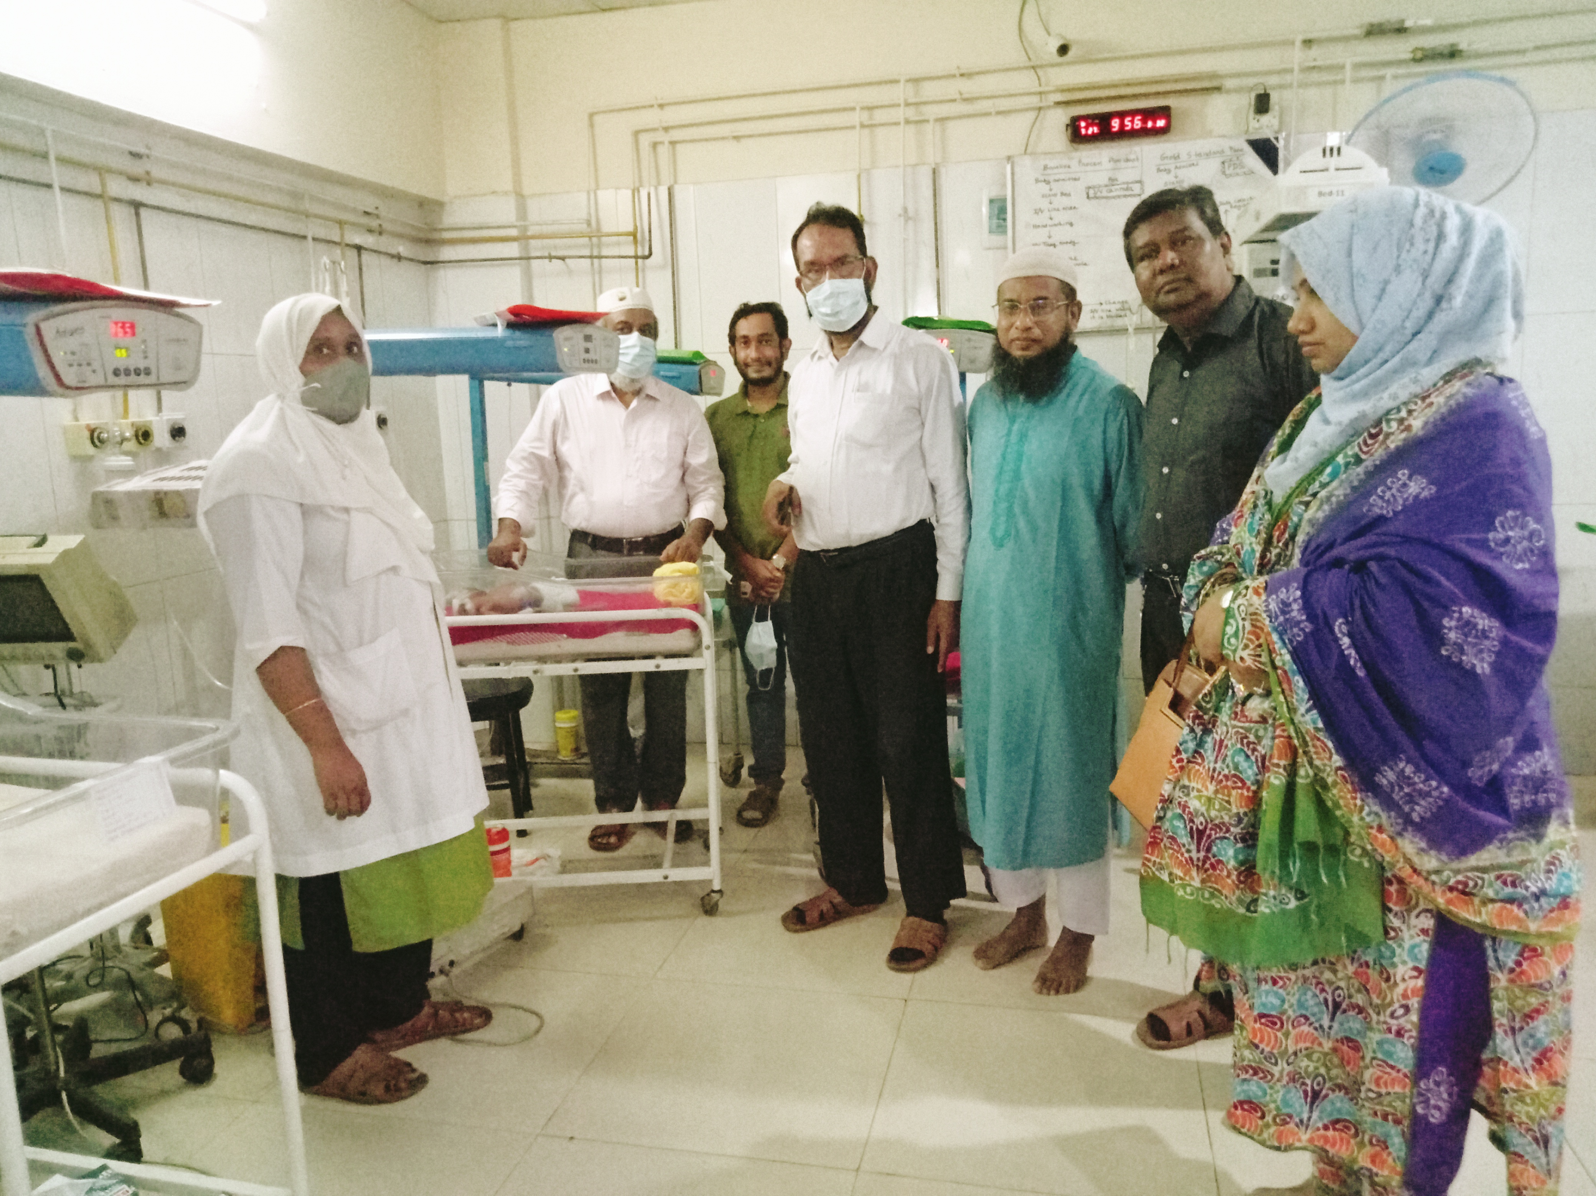

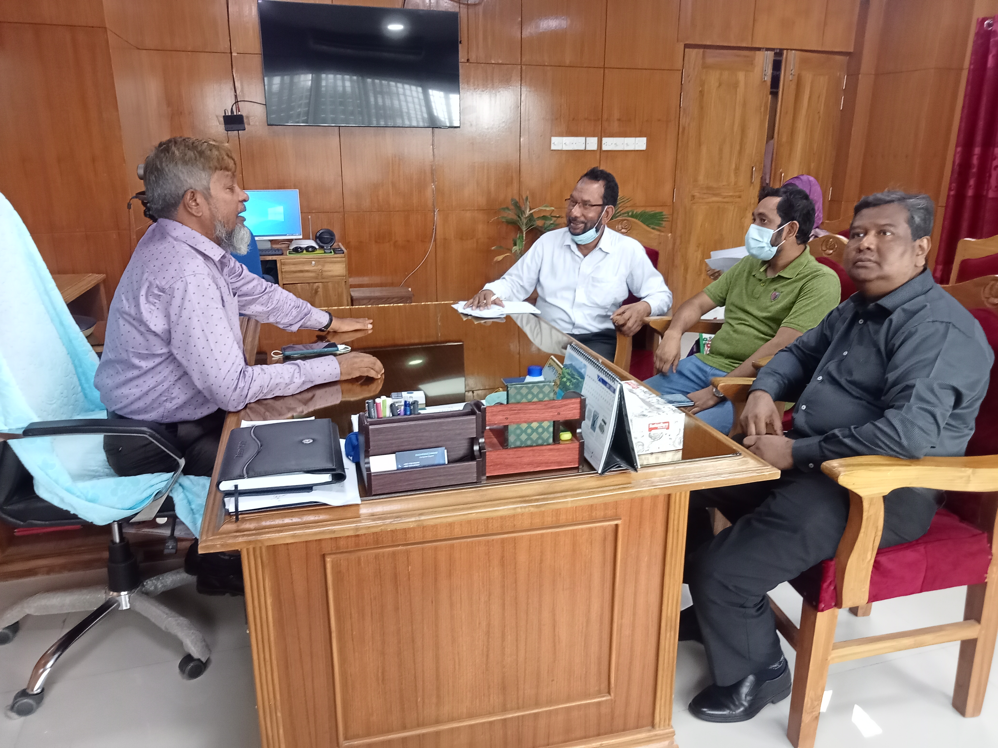
Fig: NICU of Tangail District Hospital

Fig: Discussion with the Director of Sheikh Hasina Medical College Hospital
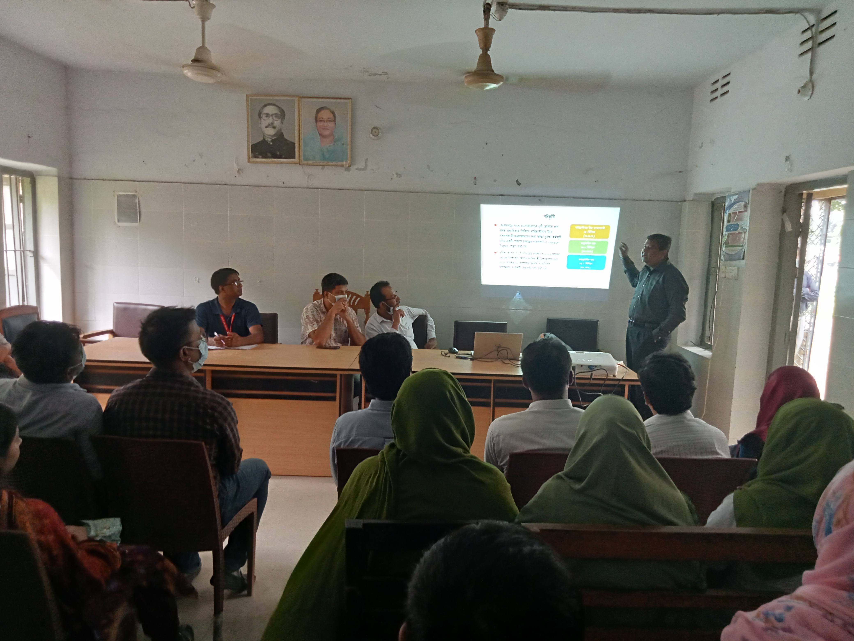

Fig: Meeting with the service providers at Nagorpur UHC
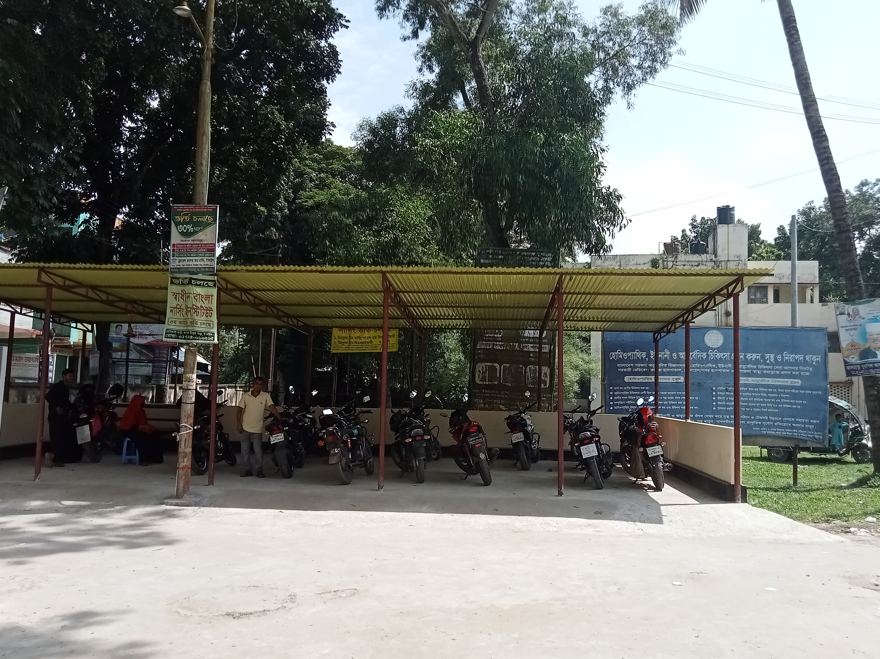

Fig: Cycle stand close to the main gate

